Aravind Pedavalli

[AravindPedavalli@lewisu.edu](mailto:AravindPedavalli@lewisu.edu)

Student ID - L30087254

[Database Systems](https://lewisuniversity.blackboard.com/webapps/blackboard/execute/courseMain?course_id=_199703_1)

ERD Model PART 3

<https://github.com/AravindPedavalli/Database-Systems>

For this assignment I designed an ER Diagram using draw.io in both physical and logical mode as shown in Fig 1 & 2.

As per the week 2 assignment I designed this by clicking on UML section and added the certain required table style and connected using the arrow.

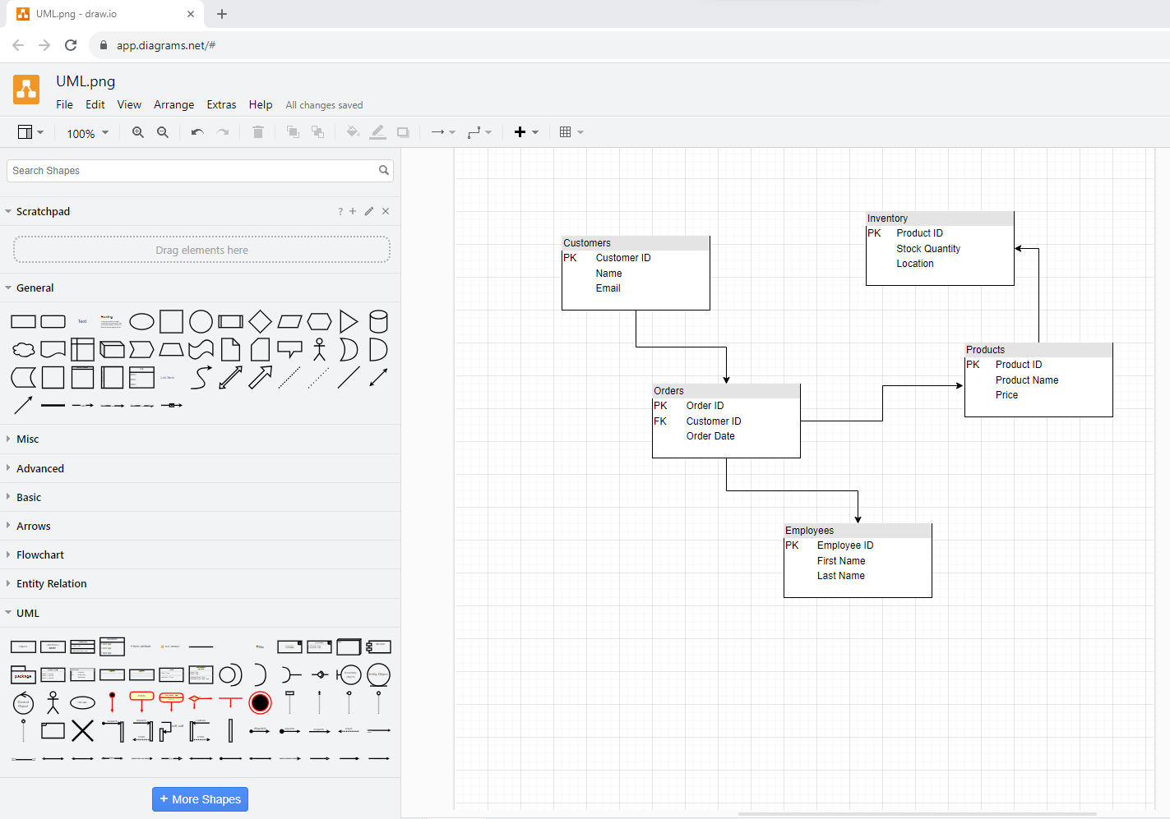

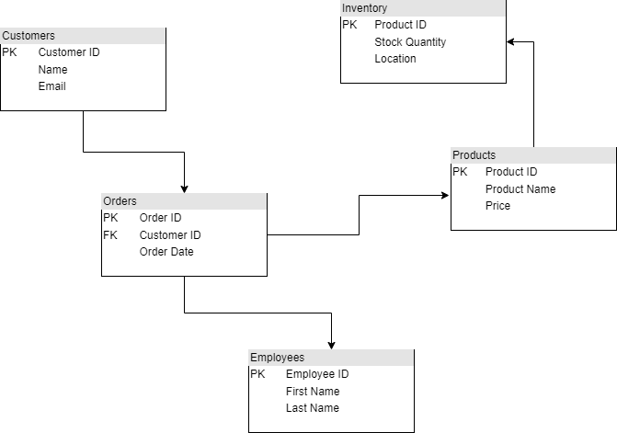

**Fig 1 UML physical mode**

After designed a physical mode I have taken the same UML to the design a logical mode by selecting a new design and there I selected Entity Relation so that I can choose the relationship connections.

In the Fig 2 I shown the design of logical mode connection **(Crows Foot).**

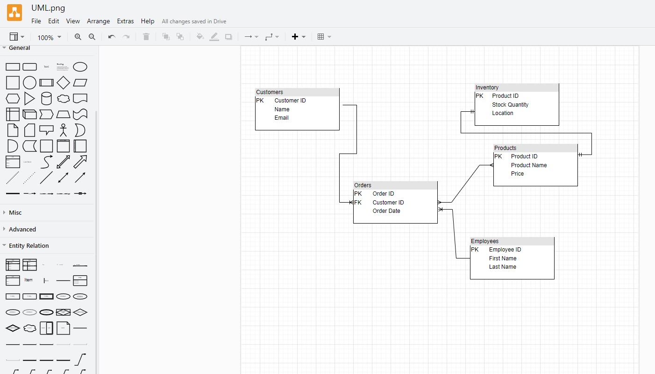

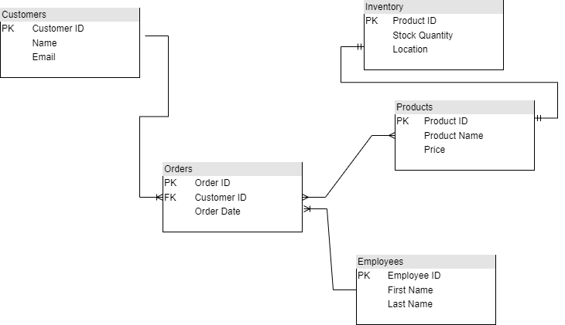

**Fig 2 ER Logical mode (Crows Foot)**

**Relationships:**

**Customer-Order Relationship:**

One-to-Many (1:N) relationship from Customer to Order, as one customer can place multiple orders.

**Order-Employee Relationship:**

Many-to-One (M:1) relationship from Order to Employee, as many orders can be handled by one employee.

**Order-Product Relationship:**

Many-to-Many (M:N) relationship between Order and Product, as one order can include multiple products, and one product can be included in multiple orders.

**Product-Inventory Relationship:**

One-to-One (1:1) relationship between Product and Inventory. If each product has a unique location, it could be one-to-one.